**FULL ADDER USING NAND GATES ONLY**

**EXP NO.7:**

AIM: To show the working of full adder using logisim.

Truth table:

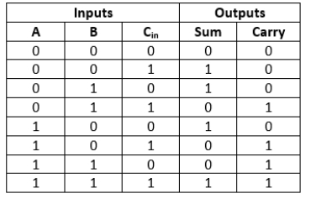

OUTPUT:

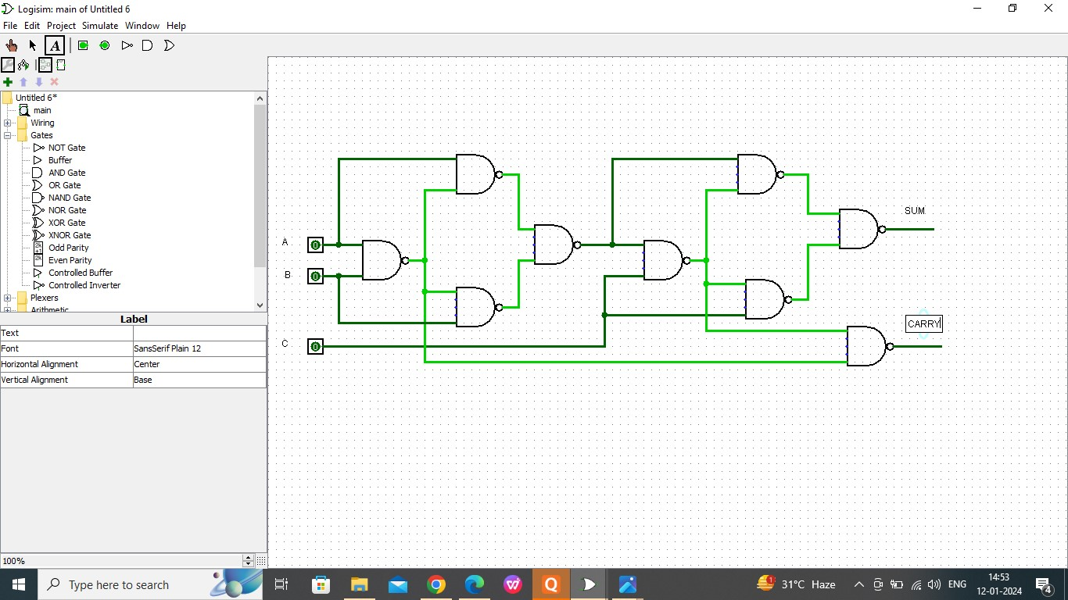

RESULT:

Thus the working of full adder has been observed successfully using logisim.